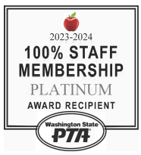
February - Maple Hills PTA Newsletter

Important Updates

The Chirp!
Upcoming Events: Science Fair & PTA Auction
Science Fair - Application Deadline Approaching!
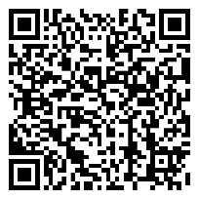
Calling all young scientists! The Maple Hills Science Fair is coming soon, and we want YOU to participate!
- Application Deadline: Submit your project proposal by March 7, 2025.
- Event Date: Science Fair & STEM Night will take place on March 28, 2025.
- Who Can Participate? All students are encouraged to explore and showcase their scientific curiosity.
- How to Apply: Visit maplehillspta.com/sciencefair for more details and to submit your application.
Scan QR For Application
📌 Don’t miss this opportunity to shine in STEM!

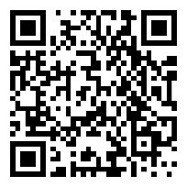
PTA Auction - Early-Bird Tickets Available Now!
🎉 Get ready for an amazing night at the Maple Hills PTA Auction on May 2, 2025!
- Early-Bird Discount: Save 15% on tickets when you purchase by March 7, 2025.
- Event Highlights: Silent & live auctions, community fun, and exclusive experiences up for bid.
- Tickets Available At: maplehillspta.ejoinme.org/tickets
Scan QR For Tickets
- Want to contribute? Donate items, experiences, or sponsor the event! Learn more at maplehillspta.com/auction.
🎟️ Secure your tickets now and support our students!

📢 Get Involved & Stay Connected! Have questions? Contact us at:
📩 Science Fair: sciencefair@maplehillspta.com
📩 Auction: auction@maplehillspta.com
📩 Volunteers: volunteers@maplehillspta.com
Thank you for supporting our school and students!

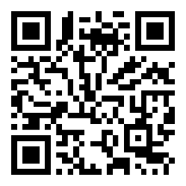
Yearbooks Are on Sale Now!
📌 Price: $27.00 per yearbook
📌 Order Deadline: April 12, 2025
📌 How to Order: https://maplehillspta.com/Packet/Yearbook
✨ Add a Special Message! ✨
💜 Regular Love Line (80 characters): $5.00
💜 Extended Love Line (160 characters): $10.00
📸 Help Us Make the Yearbook Amazing! 📸 Send your favorite school memories to Darla Vaughan, Yearbook Chair at yearbook@maplehillspta.com. Your photos will help make this yearbook extra special!
🎓 5th Grade Baby Pictures Needed! 🎓If you have a 5th grader, send their baby picture to yearbook@maplehillspta.com to be included in this year’s yearbook.
💜 Need Assistance? 💜 Scholarships are available! If you'd like a yearbook but cannot afford one, contact Mrs. Bryant at bryanta@issaquah.wednet.edu.
Order today and hold onto the memories forever! 📖✨

Scan QR To Order
PTA Auction – May 2nd!
We still need your help
to make this event a success!
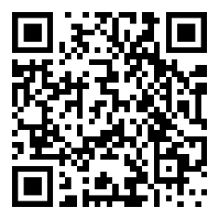
💜 Donations Needed: Gift cards, event tickets, unique experiences, and more!
💜 Sponsors Wanted: Showcase your business while supporting our school.
💜 Volunteers Needed: Help with planning, set up, or event-day support.

Every contribution makes a difference.
Proceeds from the auction are used to support our students’ programs
and events for 2 years!
Scan QR To Donate or Sponsor

To donate or sponsor:
Scan the QR Code, or contact us at President@MapleHillsPTA.com
or visit: https://www.signupgenius.com/go/10C0544AEA722A6FB6-54587335-80s to get involved.

Thank you for supporting our students!

Volunteers Make It Happen!
If you would like to volunteer or have any questions, please email volunteers@maplehillspta.com or onetimeevents@maplehillspta.com
To see more opportunities to help.
Volunteer Central:
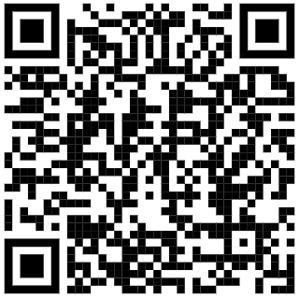

Thank You for Supporting
Maple Hills PTA Fundraising!
Your contributions to our PTA fundraising campaigns make a real difference for our students and school! A huge thank you to all the families who have participated so far—we couldn’t do it without you.
Coming Soon!
Brown Bear Car Wash Ticket Fundraiser: 3/4/25
Krispy Kreme Donut Fundraiser: 3/15/25
Field Day T-Shirt Orders Start: 4/14/25
Looking ahead, our Annual Auction on May 2nd is our main fundraising effort.
This event is crucial for supporting PTA programs, events, teacher grants, and so much more. We encourage all families to get involved by donating, sponsoring, or attending the event.
Thank you for being part of the Maple Hills family and for helping us build a stronger, more vibrant school community!

PTA Membership Renewal
Must be renewed yearly to be a member
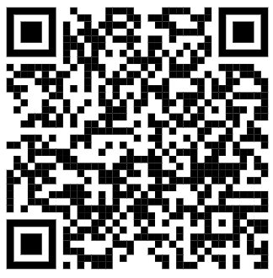
Becoming a member does not require you to be a volunteer.

